Project Introduction

Let’s understand the problem through a subset of records in the dataset as shown in the following figure:

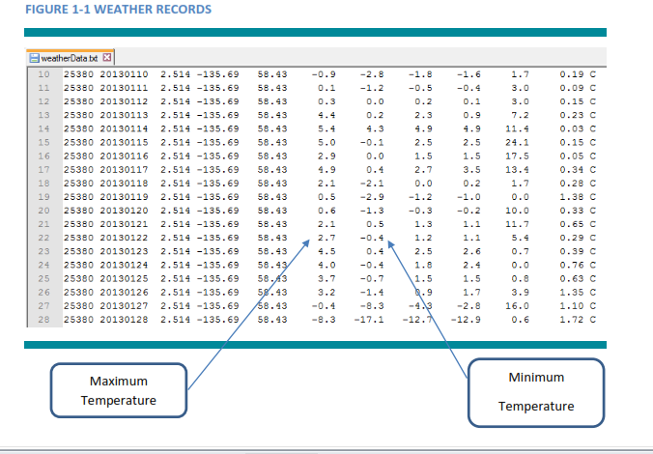

Our task is to find out the dates with maximum temperature greater than 40 **(A Hot Day)** and

minimum temperature lower than 10 **(A Cold Day)**.

Here is the sample output:

**FIGURE 1- 2 SAMPLE OUTPUT**

